DBMS LAB
Lab Assignment number 06
Name: Aamir Ansari Batch: A Roll no. 01

Aim: Experiment to study co-related queries and complex queries.

Theory:
Aggregate functions: -
Which takes set of values as input and returns single value as output.
Aggregate function generates summary value.

Sum():-The sum function returns the sum of values from given set.
Syntax:-
Select sum(distinct|all colname) from tablename
Default-all
Eg. Select sum(distinct salary) as totalsal from employee

Avg():-The Avg() function returns the average of values from given set.
Syntax:-
Select Avg(distinct|all colname) from tablename
Default-all

Eg. Select avg(salary) as Avgsal from employee

count():-The count() function returns number of values from given set.
Syntax:-
Select count(distinct|all colname) from tablename
Select count(*) from employee

Number of records
Min():-The min() function returns minimum(smallest) value from given set.
Max():-The max() function returns maximum(largest) value from given set.

--All aggregate functions by default ignores null value.
Min(),Max(),count() can be used with numeric, character,date/time columns.
Group by clause:-
Group by clause is used to form group the records based on some criteria.
Group by clause applies aggregate function on subgroup of tuples from a relation where subgroups are formed on some column value.
Eg. group by colname
--Column name is called grouping column.

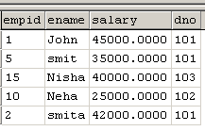
--after grouping
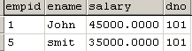
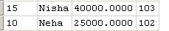

Select sum(salary) as totalsal from emp group by dno
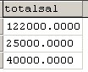

select dno,sum(salary) as totalsal from emp group by dno
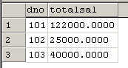

Select dno,sum(salary) as totalsal, count(*) as no_of_emp from emp group by dno
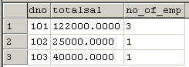

--There are restrictions on columns that we can specify in the
select list.The only columns allowed in the select list are
Grouping columns(column that we included after group by clause.
Aggregate function.

Select dno, salary as totalsal from emp group by dno --error

(not aggregate function | not grouping column)

Eg. Display dno and number of employees for every
Department those are earning salary more than 40000.

Select dno,count(empid) from emp where salary>40000
group by dno

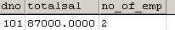

Having clause:-
Having clause is used to apply condition on group rather than tuple.
Where clause can not apply condition on group of value.

Eg. Display dno and average salary for every dept.
select dno,avg(salary) as avg_sal from emp group by dno
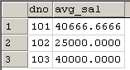

Eg. Display dno and average salary of departments where average salary of department is >=40000.
select dno,avg(salary) as avg_sal from emp group by dno having avg(salary)>=40000

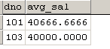

Eg. Display dno and no_of_emp of those depts where no_of_emp those are earning salary within range 30000 to 40000 are at least 2.

select dno,count(empid) as no_of_emp from emp where salary between 30000 and 45000
group by dno having count(empid)>=2
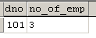

Where → Group By → Having

Co-related queries:-
Whenever a condition in the where clause of a nested query references to some attributes of a relation declared in the outer query then two queries are said to be co-related.
Correlated subquery runs once for each row selected by the outer query. It contains a reference to a value from the row selected by the outer query.

Eg. Display employee details of employees who are earning salary more than average salary of department for which they are working.
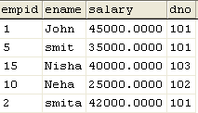

select dno,avg(salary) from emp group by dno
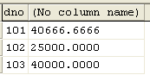

select *from emp as e1 where e1.salary>
(select avg(salary) from emp as e2 where e1.dno=e2.dno)

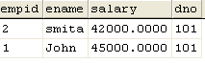

Nested subquery runs only once for the entire nesting (outer) query. It does not contain any reference to the outer query row.
Correlated subquery runs once for each row selected by the outer query

select *from emp as e1 where e1.salary>=all
(select salary from emp as e2 where e1.dno=e2.dno)
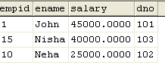
select *from emp where salary
in (select max(salary) from emp group by dno)
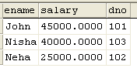

Exists and Not Exists:-
Exists and Not Exists operator is used to check where the result of co-related nested query is empty or not.
Exists:-
Exists operator return true if there is at least one tuple in the output of subquery.
Not Exists: -
Not Exists operator return true if there are no tuple in the output of subquery.(empty)
select *from dept as d where exists(select *from emp as e where e.dno=d.dno)
select *from dept as d where not exists(select *from emp as e where e.dno=d.dno)
Derived Relations
SQL allows a subquery expression to be used in the from clause.
If such an expression is used, the result relation must be given a name, and the attributes can be renamed.
Eg.
select dno from (select dno,count(*) from emp group by dno) as deptinfo(dno,noofemp) where noofemp>1
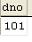

Complex Queries
-- Calculate avg,min,max,total salary and no of emp in each dept.
SELECT d_no, AVG(salary) as avg_salary, MAX(salary) as min_salary, MIN(salary) as min_salary, SUM(salary) as total_salary, COUNT(*) as no_of_employees
FROM Employee
GROUP BY d_no;
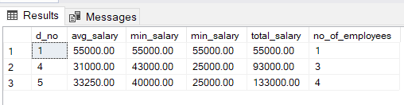

-- Display dept no and number of emp for every dept those are earning salary more than 40K.
SELECT d_no, COUNT(*) as no_of_employees
FROM Employee
WHERE salary > 40000
GROUP BY d_no;
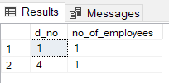

-- Display d_no, avg salary of department whose average salary is greater 40000
SELECT d_no, AVG(salary) as avg_salary
FROM Employee
GROUP BY d_no
HAVING (AVG(salary) > 40000);
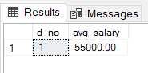

-- Display dno and no of emp of those dept where no of emp those are earning salary with-in the range 30k and 40k are atleast 2.
SELECT d_no, COUNT(*) as no_of_employee
FROM Employee
WHERE salary BETWEEN 30000 AND 40000
GROUP BY d_no
HAVING(COUNT(*) >= 2);
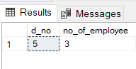

Co-related Query and nested
-- Display emp details of emp with Maximum salary in each dept
SELECT *
FROM Employee
WHERE salary IN (
SELECT MAX(salary)
FROM Employee
GROUP BY d_no
);
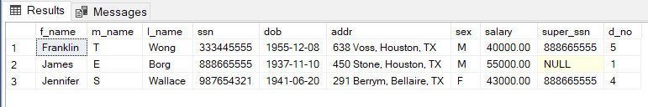

Co-related Queries
-- Display emp details of emp earning salary more than avg salary of dept for which they are working.
SELECT *
FROM Employee AS e1
WHERE e1.salary > (
SELECT AVG(salary)
FROM Employee AS e2
WHERE e1.d_no = e2.d_no
);
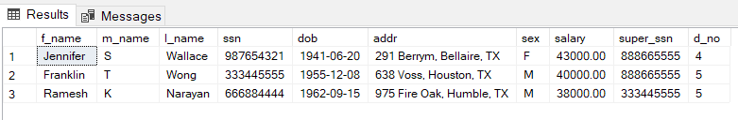

-- Display the details of those dept which have emp working for them.
SELECT *
FROM Department AS d
WHERE EXISTS (
SELECT *
FROM Employee AS e
WHERE e.d_no = d.d_no
);
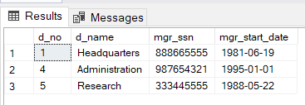

-- Display the details of those dept which have no emp working for them.
SELECT *
FROM Department AS d
WHERE NOT EXISTS (
SELECT *
FROM Employee AS e
WHERE e.d_no = d.d_no
);
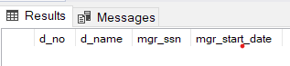

Conclusion: We have successfully studied and implemented co-related queries and complex queries.

